**Benha University: shoubra Faculty of engineering**

**Html-project**

**Topic"Artificial-Intelligence"**

**Made by:** Menna Tallah Walid Ebrahim Elaraby Eltahawy

**Academic Year**: 2020-2021 preparatory

**Sec:** 43

**Sec.No:** 12

**B.N:** 957

**Under Surpervision Of**

Dr.Ahmed Bayoumi

Dr.Shady Elmashad

Dr.Abdelhamid Attaby

**Application Brief:** Today, the amount of data that is generated, by both humans and machines, far outpaces humans’ ability to absorb, interpret, and make complex decisions based on that data. Artificial intelligence forms the basis for all computer learning and is the future of all complex decision making. As an example, most humans can figure out how to not lose at tic-tac-toe (noughts and crosses), even though there are 255,168 unique moves, of which 46,080 end in a draw. Far fewer folks would be considered grand champions of checkers, with more than 500 x 1018, or 500 quintillion, different potential moves. Computers are extremely efficient at calculating these combinations and permutations to arrive at the best decision. AI (and its logical evolution of machine learning) and deep learning are the foundational future of business decision making.

**Screenshots:**

* **Main links**

D:\html-project\images\Capture.PNG

* **Some of articles**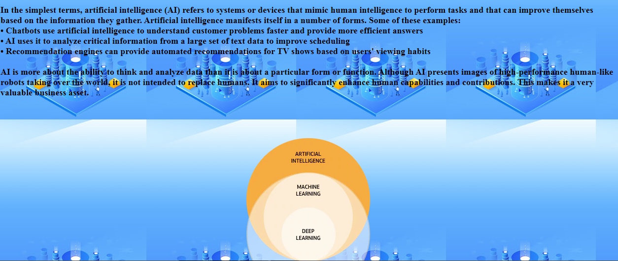

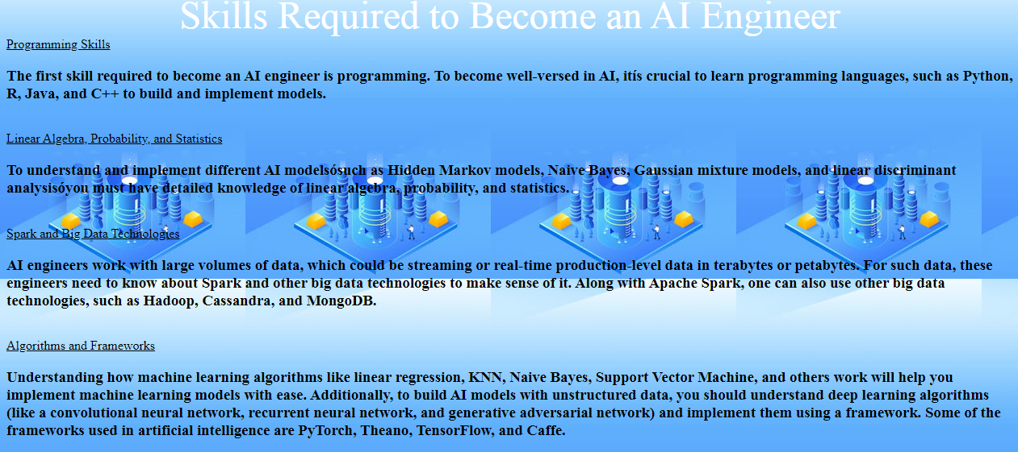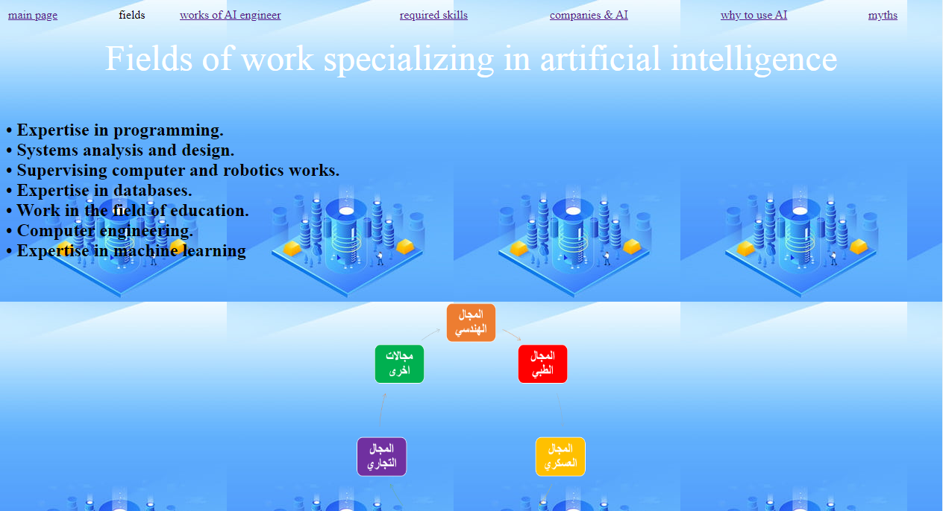

* **Some of photos** 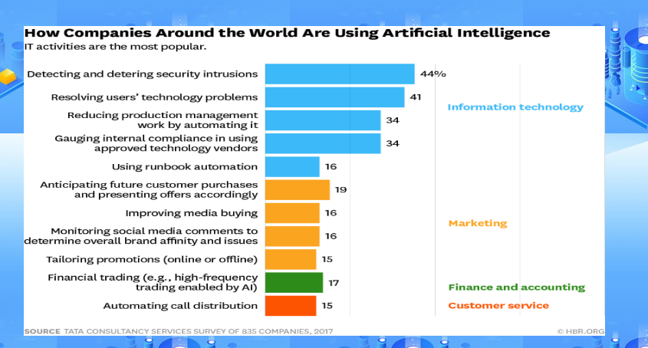
* **Some of tables & links**

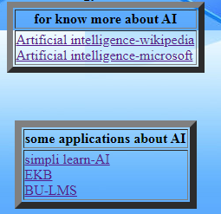

**Source Code:**

**Codes of P1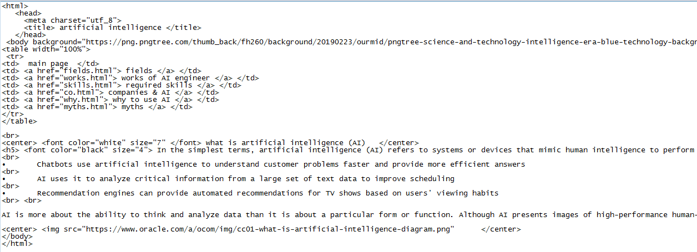 Codes of p2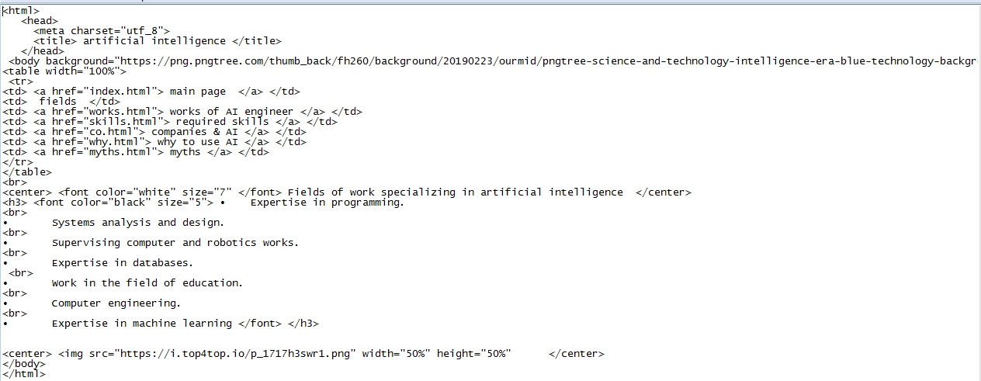 Codes of p3**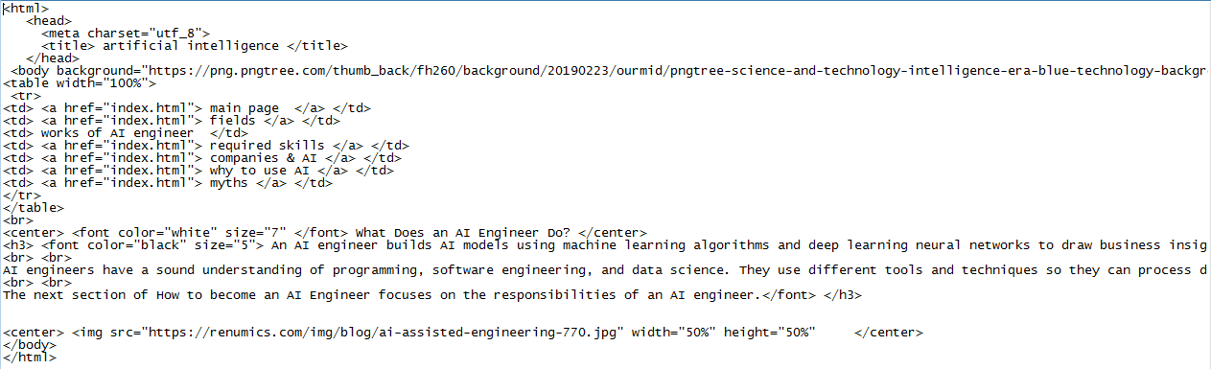

**Codes of p4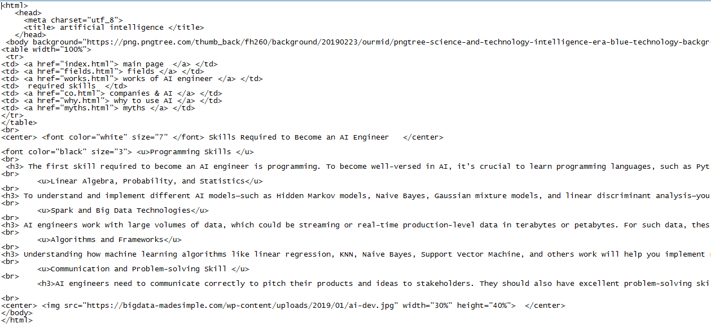 Codes of p5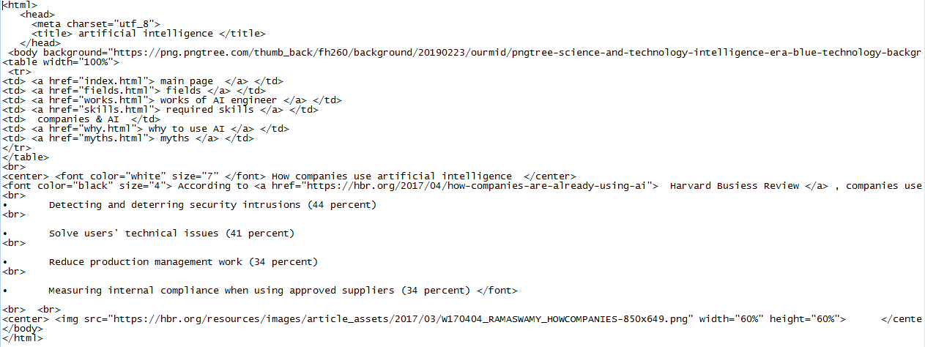 Codes of p6**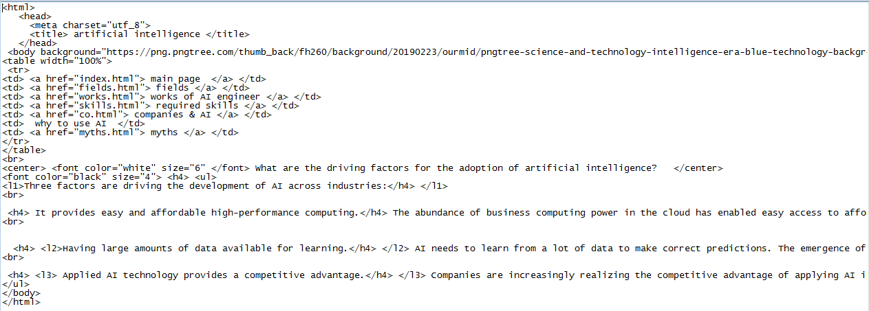

**Codes of p7** 